Musictheory.net Instructions
- Go to musictheory.net on your school computer (if you type it in wrong, it will show up blocked.
- Click on “Exercises”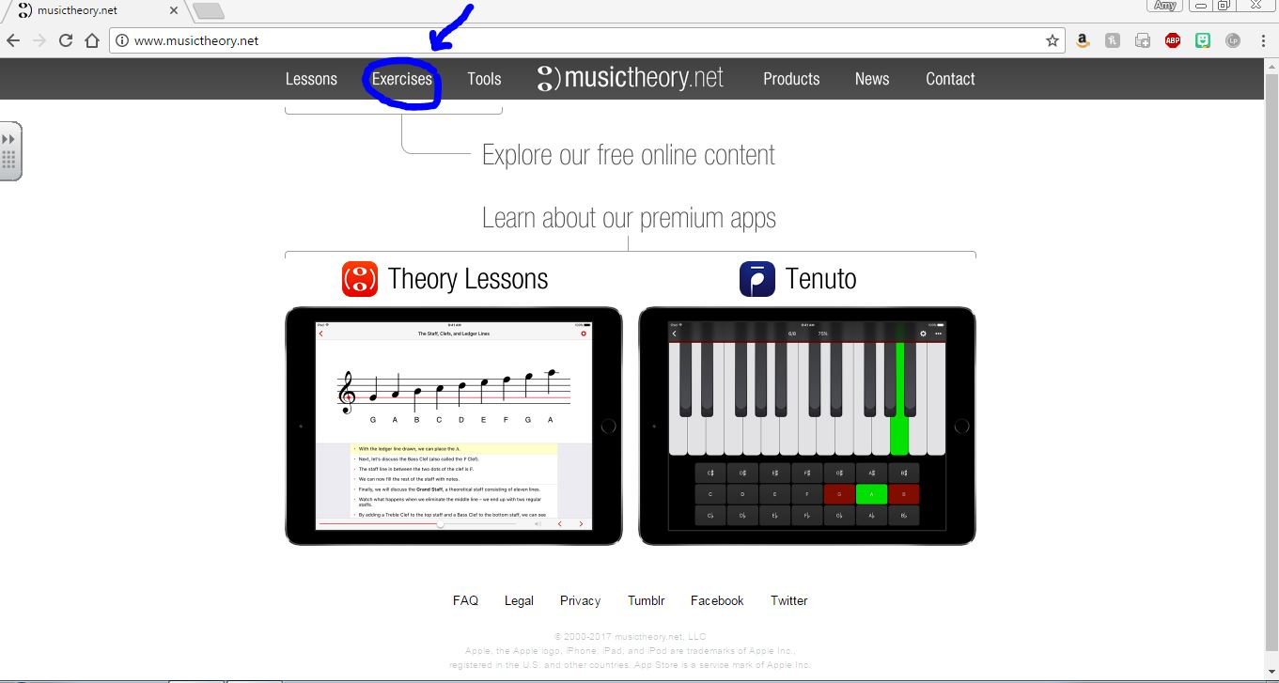
- Click on “Note Identification”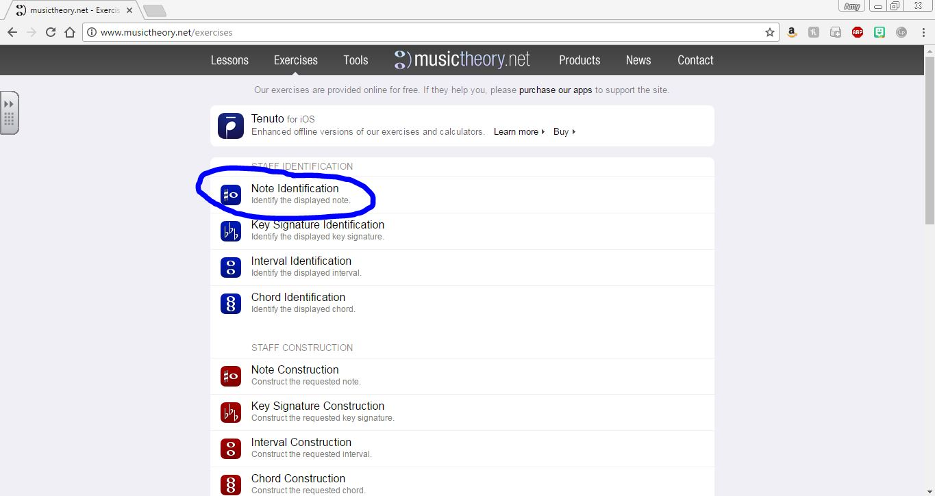
- Click on Settings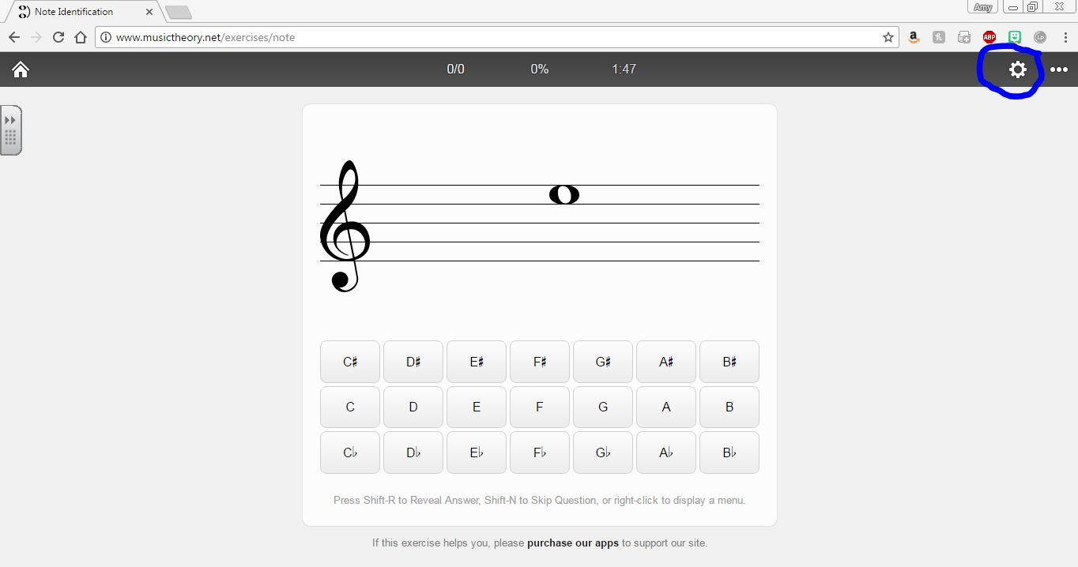
- Follow these guidelines for the settings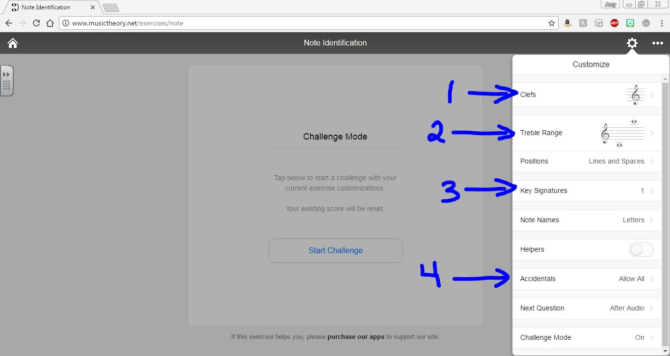
  - Step 1- Change the clef to the appropriate one for your instrument
  - Step 2- Change the range to the following
    - 7th and 8th Grades- Everyone but Tubas- 3 ledger lines above and 4 below. Tubas- Top line of the staff and 5 lines below.
    - 6th grade- 2 Ledger lines above and 3 ledger lines below
  - Step 3- Key signatures
    - 8th grade- Add all the key signatures for your instrument for Concert Bb, Eb, Ab, F, C and G scales
    - 7th grade- Add the key signatures for your instrument for Concert Bb, Eb and F.
    - 6th grade- Add the Key signature for your instrument for Concert Bb and F.
  - Step 4- Accidentals
    - 7th and 8th grades- allow accidentals
    - 6th grade- no accidentals

- Click “Challenge mode”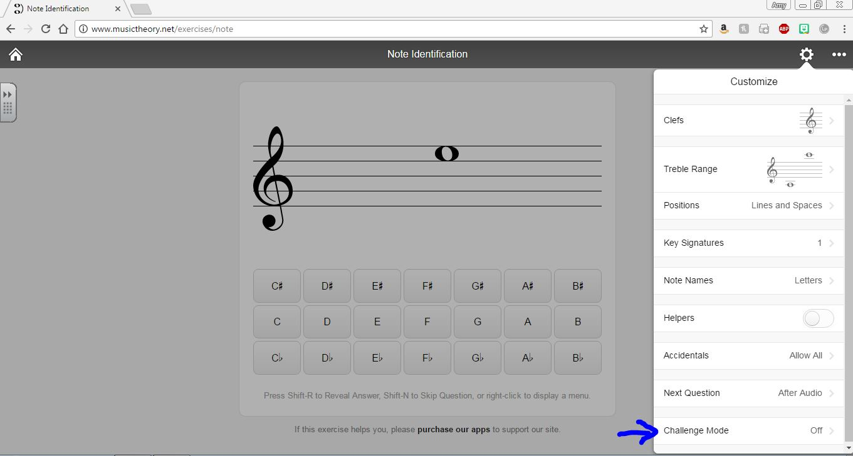
- Guidelines for Challenge mode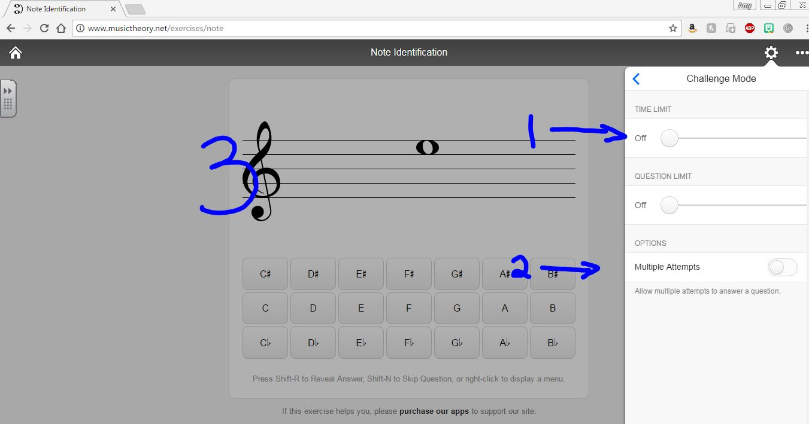
  - Step 1- Time limit. Set this to 5 minutes
  - Step 2- Multiple attempts, allow
  - Step 3 Click somewhere outside of the settings box.
- Bookmark this page to save for practice records by clicking on the star in your browser.